**Autonomous B2B Sales**

**Agent with Multi-Step Reasoning**

AI-Driven Lead Research, Outreach & Decision Intelligence Platform

**Project Overview:**

The AI-Powered B2B Lead Generation & Outreach Automation System is an intelligent, end-to-end platform designed to automate the complete B2B outreach lifecycle from company discovery and lead research to personalized email generation, reply monitoring, follow-ups, and meeting scheduling. Built for sales teams, founders, recruiters, growth marketers, and business development professionals, the system replaces manual lead research and outreach activities with a scalable, AI-driven workflow that improves efficiency and consistency.

Traditional B2B outreach involves time-consuming and subjective tasks such as company analysis, decision-maker identification, email drafting, response tracking, and meeting coordination. This platform addresses these challenges by transforming unstructured web data and email interactions into structured, actionable intelligence. Powered by LangGraph, Large Language Models (LLMs), FastAPI, SMTP/IMAP automation, Google Calendar integration, and a React-based frontend, the system simulates the workflow of an experienced sales professional. By combining AI reasoning with human-in-the-loop approvals and real-time monitoring, it delivers a transparent, controlled, and repeatable outreach process that accelerates pipeline generation while maintaining quality and compliance.

**Scenario 1: Sales Outreach & Lead Generation**

Sales teams and business development professionals often rely on manual processes for identifying companies, researching websites, finding decision-makers, drafting personalized emails, and tracking responses. These activities are time-consuming, repetitive, and highly dependent on individual judgment, resulting in inconsistent outreach quality and slower pipeline creation.

The AI-Powered B2B Lead Generation & Outreach Automation System simplifies this workflow by starting from a simple business query such as *“SaaS companies in fintech.”* The platform automatically discovers companies, analyses websites, validates contact emails, and evaluates leads using Ideal Customer Profile (ICP) rules. It then generates AI-powered outreach emails that users can review and approve before sending, monitors replies, triggers follow-ups, and assists in scheduling meetings through Google Calendar—allowing sales teams to focus on high-value conversations while improving efficiency and consistency.

**Scenario 2: Recruitment, Agency Outreach & Business Development**

Recruitment agencies, founders, and growth teams frequently conduct large-scale outreach to pitch services, partnerships, or hiring solutions. Managing this process manually becomes difficult to scale, especially when tracking responses, follow-ups, and meeting coordination across multiple prospects.

Using the AI-powered platform, users can run structured outreach campaigns targeting specific industries or company profiles. The system automates company research, generates tailored outreach emails aligned with organizational offerings, and ensures compliance through human-in-the-loop approvals. As prospects respond, the platform tracks engagement, manages follow-ups, and enables quick meeting scheduling, transforming outreach into a structured, measurable, and repeatable process without increasing manual workload.

**Architecture Overview:**

The AI-Powered B2B Lead Generation & Outreach Automation System is built on a modular, multi-layered architecture designed to automate the complete outreach workflow while maintaining scalability and human control. At its core, the system uses LangGraph to model the outreach lifecycle as a stateful graph, where each node represents a distinct stage such as company discovery, research, lead qualification, email generation, sending, monitoring, follow-ups, and meeting scheduling. This graph-based design enables conditional routing, persistent campaign state, and seamless pausing or resuming of campaigns without losing context.

The intelligence layer of the platform is powered by Large Language Models (LLMs) accessed through Groq using LLaMA-based models. These models perform deep website analysis, extract business intent signals, generate personalized outreach emails, and support follow-up logic. Rule-based Ideal Customer Profile (ICP) evaluation is combined with AI-assisted reasoning to ensure lead qualification remains explainable, consistent, and aligned with business goals. This hybrid approach balances automation with reliability and transparency.

The orchestration and intelligence layers are exposed through a FastAPI backend, which acts as the communication bridge between the AI workflow and the user interface. Email engagement is handled through SMTP and IMAP integration for sending emails and tracking replies, while Google Calendar and Google Meet APIs enable automated meeting scheduling. A React-based frontend, supported by WebSockets for real-time updates, allows users to configure campaigns, review AI-generated content, approve actions, and monitor outreach progress through an interactive and responsive interface.

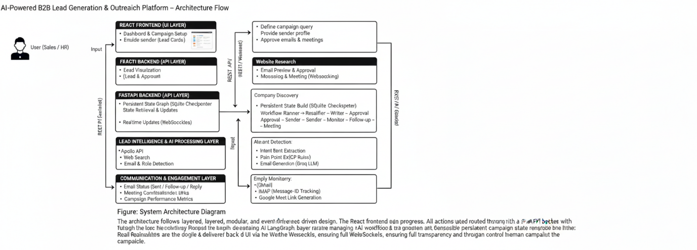

Figure : System architecture diagram

**Core Technologies:**

* **LangGraph (Workflow Orchestration):** LangGraph models the B2B outreach pipeline as a stateful graph, managing node execution, conditional routing, human approvals, and persistent campaign state across long-running workflows.
* **Large Language Models (Groq / LLaMA):** LLMs perform intelligent website analysis, intent detection, email drafting, follow-up generation, and reasoning-based decisions, enabling human-like sales outreach at scale.
* **FastAPI (Backend API Layer):** FastAPI exposes the LangGraph workflow through REST APIs and WebSocket endpoints. It manages campaign lifecycle, approvals, monitoring actions, and frontend–backend communication.
* **React.js (Frontend Application):** React provides a dynamic, component-based user interface for campaign setup, lead visualization, email preview, approvals, and monitoring dashboards.
* **WebSockets (Real-Time Communication):** WebSockets enable real-time updates for campaign status, email approvals, reply detection, and monitoring events without requiring manual refresh.
* **SMTP (Email Sending Engine):** SMTP is used to send AI-generated outreach and follow-up emails securely through configured mail servers.
* **IMAP (Reply Monitoring & Tracking):** IMAP continuously monitors inboxes to detect replies using message IDs, enabling automated response handling and follow-up workflows.
* **Google Calendar API:** Used to create calendar events automatically when meetings are scheduled with prospects.
* **Google Meet Integration:** Generates secure Google Meet links for scheduled meetings, completing the outreach-to-engagement loop.
* **Apollo API (Company Data Source):** Apollo API is used to discover companies based on industry, size, and keywords, providing structured lead data for research and qualification.
* **Web Crawling & Scraping (Requests, BeautifulSoup, DDGS):** These tools extract real-time website content and business information from company websites when API data is unavailable
* **SQLite (Persistent State & Checkpointing):** SQLite stores LangGraph checkpoints, campaign states, and monitoring data, allowing campaigns to pause, resume, and recover reliably.
* **Pydantic (Data Validation & Schemas):** Pydantic enforces structured data models for API requests, responses, and internal state consistency across the system.
* **Axios (Frontend API Client):** Axios manages HTTP communication between the React frontend and FastAPI backend, handling request/response workflows efficiently.
* **Python Utility Libraries:** Libraries such as requests, dns.resolver, and email support networking, domain validation, email parsing, and backend utility functions.

**Component-Wise Architecture:**

|  |  |
| --- | --- |
| **Component** | **Description** |
| **React User Interface** | Provides an interactive dashboard for campaign creation, lead visualization, email preview, approvals, and monitoring. Enables users to control outreach workflows and view real-time updates through a responsive web interface. |
| **API Service Layer** | Acts as the communication bridge between the frontend and backend. Handles REST API calls and WebSocket connections for real-time campaign updates, approvals, and monitoring events. |
| **FastAPI Backend** | Exposes the outreach workflow as REST APIs and WebSocket endpoints. Manages campaign lifecycle, user decisions, state updates, and coordination with the LangGraph engine. |
| **LangGraph Orchestration Engine** | Controls the entire outreach lifecycle as a stateful graph. Handles workflow sequencing, conditional routing, human-in-the-loop approvals, and persistent campaign state management. |
| **Company Discovery Module** | Identifies potential companies using Apollo API and web search based on user-defined queries such as industry, location, or company size. |
| **Website Research & Crawling Module** | Crawls company websites to extract business context, services, keywords, and decision-maker signals for lead enrichment and evaluation. |
| **Lead Qualification Engine** | Evaluates researched companies against Ideal Customer Profile (ICP) rules using both rule-based scoring and AI-assisted reasoning to determine lead quality. |
| **AI Email Generation Module** | Generates professional, personalized outreach and follow-up emails using Large Language Models based on company context and sender profile. |
| **Human Approval Module** | Introduces controlled decision points where users can approve or reject email sending and meeting scheduling, ensuring transparency and compliance. |
| **Email Sending Module (SMTP)** | Sends approved outreach and follow-up emails securely through configured SMTP servers. |
| **Reply Monitoring Module (IMAP)** | Monitors inboxes to detect replies using message identifiers and triggers follow-up or meeting workflows based on response status. |
| **Follow-Up Automation Module** | Automatically generates and sends follow-up emails when no reply is received within defined time intervals. |
| **Meeting Scheduling Module** | Integrates with Google Calendar and Google Meet APIs to schedule meetings and generate conference links when prospects respond positively. |
| **Persistent State & Checkpointing Module** | Stores campaign state, monitoring data, and workflow checkpoints using SQLite, allowing campaigns to pause, resume, and recover reliably. |
| **Notification & Real-Time Update Module** | Uses WebSockets to push live updates such as campaign status, email approvals, replies, and meeting creation to the frontend. |

**Pre-requisites:**

1. **Python Environment Setup:** Install Python 3.9 or higher and create a dedicated virtual environment to ensure clean dependency management for backend services, AI orchestration, and automation workflows.

Official Download: <https://www.python.org/downloads/>

1. **Backend Dependency Installation:** All backend dependencies required for AI workflow orchestration, API handling, email automation, and persistence must be installed using a virtual environment and requirements.txt.

**Key libraries include:** LangGraph, LangChain, Groq SDK, FastAPI, Uvicorn, SQLite, BeautifulSoup & Requests, SMTP & IMAP, Google API Client.

FastAPI Documentation: <https://fastapi.tiangolo.com/>

LangGraph Documentation: <https://langgraph.langchain.com/>

LangChain Documentation: <https://python.langchain.com/>

1. **Frontend Environment Setup:** Install Node.js (v18 or higher) to run the React-based frontend application.

Node.js Official Download: <https://nodejs.org/>

React Documentation: <https://react.dev/>

1. **Large Language Model (LLM) Configuration:** Groq API KeyRequired for AI-powered email drafting, lead analysis, and follow-up generation.

Groq Official Website: <https://groq.com/>

Groq API Documentation: <https://console.groq.com/docs>

1. **Lead Data Provider Configuration:** Apollo API Key Required for live company discovery and B2B lead sourcing.

Apollo Official Website: <https://www.apollo.io/>

Apollo API Documentation: <https://apolloio.github.io/apollo-api-docs/>

1. **Email Service Configuration (SMTP & IMAP):** Required for sending outreach emails and tracking replies automatically.

* SMTP: Gmail SMTP server
* IMAP: Gmail IMAP server
* App password required for secure authentication

Gmail SMTP Setup: <https://support.google.com/mail/answer/7126229>

1. **Google Calendar & Meet Integration:** Required for automatic meeting scheduling and Google Meet link generation.

Steps:

* Create a project in Google Cloud Console
* Enable Google Calendar API
* Generate OAuth credentials (credentials.json)
* Authenticate and store tokens securely

Google Cloud Console: <https://console.cloud.google.com/>

1. **Database Setup:** The system uses SQLite for persistent LangGraph state management.

* No separate installation required
* Database file is automatically created at runtime

SQLite Documentation: <https://www.sqlite.org/docs.html>

1. **Development & Testing Tools**

Visual Studio Code: <https://code.visualstudio.com/>

PyCharm Community Edition: <https://www.jetbrains.com/pycharm/>

Postman (API Testing): <https://www.postman.com/>

1. **Browser Requirements**

A modern browser is required to access the frontend dashboard and monitoring interface.

Recommended browsers:

* Google Chrome
* Microsoft Edge
* Mozilla Firefox

Google Chrome: <https://www.google.com/chrome/>

Mozilla Firefox: <https://www.mozilla.org/firefox/>

**Project Flow:**

1. **Environment Setup and Dependency Configuration:**

* **Activity 1.1:** Obtain Groq / LLaMA API Key for enabling AI reasoning and email generation.
* **Activity 1.2:** Apollo Account Creation for accessing real-time company and lead data.
* **Activity 1.3:** Environment Setup & Dependency Installation for configuring backend frontend and API services.

1. **Core AI Workflow & Lead Intelligence Pipeline**

* **Activity 2.1:** Company Discovery & Research Pipeline using Apollo search and intelligent web crawling.
* **Activity 2.2:** Lead Research & Enrichment extracting emails roles industry intent and pain points.
* **Activity 2.3:** Lead Qualification Engine applying ICP rules scoring and qualification logic.

1. **AI-Powered Email Generation & Outreach Automation**

* **Activity 3.1:** Cold Email Generation creating personalized outreach emails using LLM prompts.
* **Activity 3.2:** Human-in-the-Loop Approval allowing manual review before sending outreach emails.
* **Activity 3.3:** Email Sending Engine delivering approved emails securely via SMTP servers.

1. **Monitoring, Follow-ups & Meeting Scheduling**

* **Activity 4.1:** Reply Monitoring System tracking email replies and updating campaign status.
* **Activity 4.2:** Automated Follow-up Workflow sending follow-ups based on time and response status.
* **Activity 4.3:** Meeting Scheduling Automation creating calendar events and Google Meet links.

1. **MILESTONE 5: Frontend Integration & User Experience**

* **Activity 5.1:** Campaign Setup & Configuration UI collecting campaign query sender and mode details.
* **Activity 5.2:** Campaign Dashboard & Lead Visualization presenting leads scores progress and analytics.
* **Activity 5.3:** Email Preview & Approval Interface displaying drafted emails for user confirmation.

1. **Monitoring Dashboard, Testing & Deployment**

* **Activity 6.1:** Campaign UI Input & Execution Flow Validation validating forms navigation and execution flow.
* **Activity 6.2:** Email Approval, Sending & Follow-up Visibility confirming sent emails follow-ups and mailbox view.
* **Activity 6.3:** Monitoring, Reply Detection & Meeting Scheduling validating reply detection and meeting workflows.
* **Activity 6.4:** Deployment Preparation & Final Validation ensuring stable deployment and production readiness.

**MILESTONE 1: Environment Setup and Dependency Configuration**

This milestone establishes the foundational technical environment required for the successful development and execution of the AI-powered B2B Lead Generation & Outreach Automation platform. It focuses on configuring all essential system prerequisites, including backend services, frontend frameworks, external APIs, and secure credential management. Proper setup of programming environments, dependency installation, and project structure ensures that all subsequent development stages operate on a stable, secure, and well-organized foundation.

**Activity 1.1: Obtain Groq / LLaMA API Key**

* Visit the official Groq Console: <https://console.groq.com/>
* Sign in or create a new account to access LLaMA model APIs.

Figure : Groq Home Page

* Click on Start Building that navigate to dashboard.

Figure : Groq Dashboard

* Navigate to the **API Keys** section in the dashboard.
* Click **Create API Key**, then assign a recognizable name such as B2B_Planner.

Figure : Creating API Key

* Copy the generated key and store it securely in your project’s .env file.

Figure : API Key

**Activity 1.2: Apollo Account Creation**

* Open the official Apollo website: <https://www.apollo.io/>

Figure : Apollo home page

* Click on the “Sign Up” button located at the top-right corner of the homepage.
* Register using:  
  – Work email address  
  – Google account (recommended)

Figure : Sign option

* After successful registration, you will be redirected to the Apollo Dashboard.

Figure : Apollo Dashboard

* From the Apollo dashboard, click on your profile icon (top-right corner).

Navigate to: Settings → Integrations → API

* Locate the API Keys section:
  1. Click on “Create API Key”. Provide a meaningful name for the key, for example: B2B_Lead_Generation_Project
  2. Click Generate to create the API key.
  3. Copy the generated API key and store it securely.

Figure : API Key

**Activity 1.3: Environment Setup & Dependency Installation**

* Create a virtual environment for the project:

Figure 10: Creating & Activating Environment

* Install project dependencies:



Figure 11: Installing requirements

* Making a .env for securing the Gemini API Key as paste the api key here:

Figure 12: .env File

* Set up the project structure for modular development:

Figure 13: Folder Structure

**MILESTONE 2: Core AI Workflow & Lead Intelligence Pipeline**

This milestone forms the backbone of the platform by implementing the core AI-driven workflow responsible for lead discovery and intelligence generation. It focuses on transforming raw company data into structured, actionable insights through automated research, enrichment, and qualification. By leveraging a LangGraph-based orchestration system, this stage ensures consistent state management, explainable decision-making, and scalable processing of lead intelligence across campaigns.

**Activity 2.1: Company Discovery & Research Pipeline**

* Implement company search using Apollo API and web search fallback.

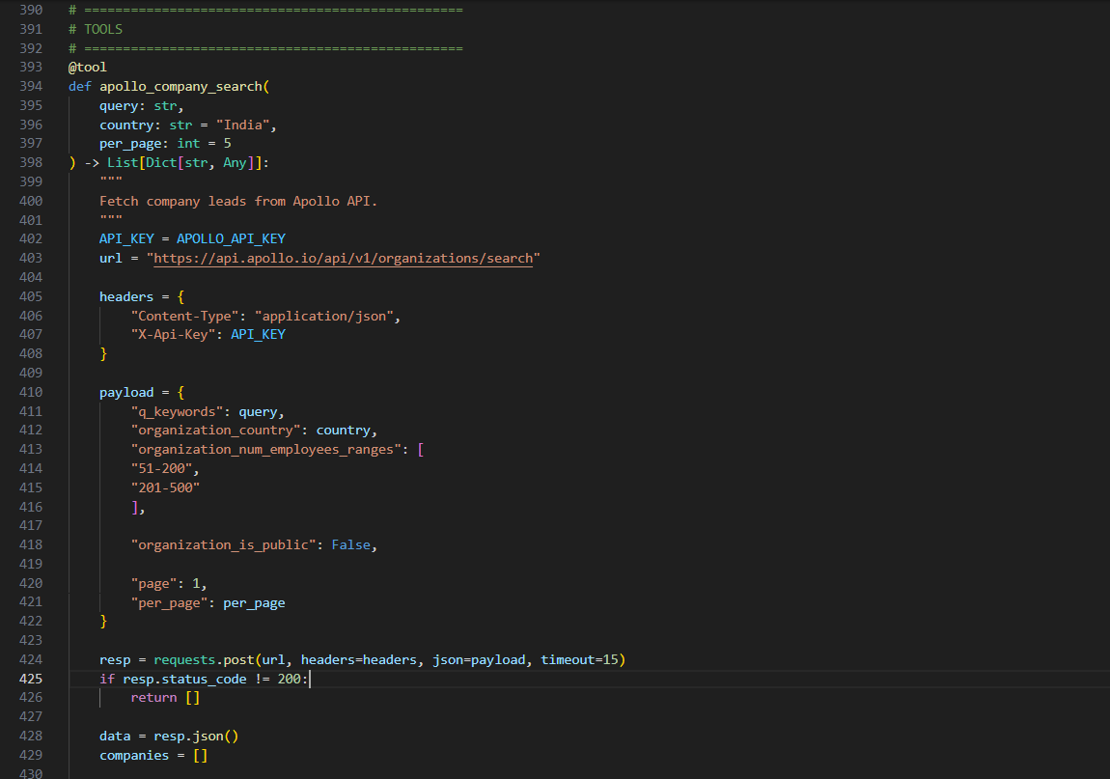

Figure 14: Apollo tool

Figure 15: Setting the sates

* Filter non-business domains and invalid websites.

Figure 16: Web Tool

* Crawl company websites to extract structured textual content.

Figure 17: Deep Search tool

**Activity 2.2: Lead Research & Enrichment**

* Extract validated email addresses from company websites.

Figure 18: Email extract and validate

* Detect decision-maker roles such as CEO, CTO, Founder, and Directors.

Figure 19: Position Finder

* Identify industry, company size, intent signals, and pain points.

Figure 20: Extracting information using the LLM

Figure 21: Summary for the extracted text

Figure 22: Storing the values in state

**Activity 2.3: Lead Qualification Engine**

* Implement rule-based ICP (Ideal Customer Profile) scoring logic.

Figure 23: ICP Scoring

* Extracting leads based on industry match, company size, intent confidence, from apollo search.

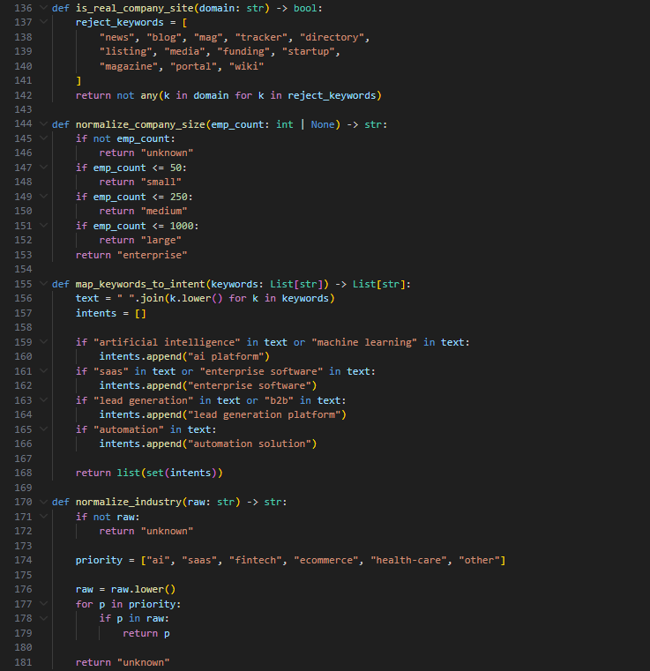

Figure 24: Extracting information from Apollo

Figure 25: Extractor

* Classify leads as qualified or unqualified with explainable scoring.

Figure 26: Qualifiers node

**MILESTONE 3: AI-Powered Email Generation & Outreach Automation**

This milestone introduces intelligent communication capabilities that automate the outreach process while preserving human control. It focuses on generating personalized, context-aware emails using large language models and ensuring that all outbound communication is reviewed and approved by the user. Secure email delivery, traceable message handling, and transparent workflow execution are emphasized to ensure professional and reliable outreach operations.

**Activity 3.1: Cold Email Generation**

* Design structured prompts for LLM-based email drafting.

Figure 27: LLM Setup

* Generate professional subject lines and email bodies using Groq LLM.

Figure 28: Prompting for LLM

Figure 29: Updating the state

* Personalize content using company context, pain points, and sender profile.

Figure 30: Updating State

**Activity 3.2: Human-in-the-Loop Approval**

* Implement approval checkpoints for outbound email sending.

Figure 31: Approval node

* Pause workflow execution until explicit user approval is received with human decision.

Figure 32: Meet Approval

**Activity 3.3: Email Sending Engine**

* Implement secure SMTP-based email delivery.

Figure 33: SMTP

Figure 34: Sate Update

* Attach unique message IDs for tracking replies.

Figure 35: Unique ID

* Log sent email metadata for monitoring and reporting.

Figure 36: Log Setup

**MILESTONE 4: Monitoring, Follow-ups & Meeting Scheduling**

This milestone manages post-outreach engagement by continuously tracking responses, triggering follow-up communication, and facilitating meeting coordination. It ensures that email replies are detected accurately, follow-ups are executed ethically and strategically, and meeting requests are handled seamlessly. This stage bridges the gap between initial outreach and meaningful business interaction, maintaining engagement continuity and visibility.

**Activity 4.1: Reply Monitoring System**

* Monitor inbox using IMAP to detect replies using message headers.

Figure 37: Monitoring the email

* Update campaign state when replies are received.

Figure 38: Monitor node

**Activity 4.2: Automated Follow-up Workflow**

* Trigger follow-up emails based on time thresholds.

Figure 39: Follow up emails

* Generate polite, context-aware follow-up messages using LLM.

Figure 40: Generating cold email

* Limit follow-ups to predefined stages to avoid spamming.

Figure 41: Follow up conditions

**Activity 4.3: Meeting Scheduling Automation**

* Allow human confirmation for meeting scheduling.

Figure 42: Meet Decision

* Create Google Calendar events with Google Meet links.

Figure 43: Meet Setup

* Store meeting metadata in campaign state.

Figure 44: Storing the data

**MILESTONE 5: Frontend Integration & User Experience**

This milestone integrates all backend intelligence into a cohesive, user-friendly frontend interface. It focuses on providing users with intuitive tools for campaign configuration, lead visualization, email review, and progress monitoring. Emphasis is placed on real-time updates, responsive design, and clarity of information presentation, enabling users to interact confidently with complex AI-driven workflows.

**Activity 5.1: Campaign Setup & Configuration UI**

* Build campaign creation interface with mode selection.
* Capture sender profile details for email personalization.
* Support resuming existing campaign threads.

Figure 45: Campaign Setup

Figure 46: Campaign Setup

Figure 47: Campaign Setup

Figure 48: Campaign Setup

Figure 49: Campaign View

Figure 50: Campaign View

Figure 51: Campaign View

Figure 52: Campaign View

**Activity 5.2: Campaign Dashboard & Lead Visualization**

* Display discovered and qualified leads using visual cards.
* Show intent signals, pain points, scores, and summaries.
* Provide real-time campaign statistics and progress indicators.

Figure 53: Dashboard

Figure 54: Dashboard

Figure 55: Dashboard

Figure 56: Dashboard

Figure 57: Dashboard

Figure 58: Dashboard

Figure 59: Dashboard

**Activity 5.3: Email Preview & Approval Interface**

* Display drafted emails before sending.
* Enable approve/reject actions from the UI.
* Reflect real-time status updates using WebSockets.

Figure 60: Email Preview

**MILESTONE 6: Monitoring Dashboard, Testing & Deployment**

This milestone focuses on validating the end-user interaction flow of the AI-powered B2B Lead Generation & Outreach Automation platform. The objective is to ensure that all UI-driven actions such as campaign setup, email approval, sending emails, follow-ups, reply monitoring, and meeting scheduling behave correctly and reflect accurately across the dashboard, mailbox, and monitoring views.

**Activity 6.1: Campaign UI Input & Execution Flow Validation**

* Validate the pages rendering correctly across the desktop.

Figure 61: Home Page

Figure 62: About Section

Figure 63: Campaign History

* Validate the **Campaign Setup UI**, ensuring users can:  
  – Select campaign mode  
  – Enter a valid search query  
  – Provide sender profile details (company name, role, description)  
  – Resume an existing campaign using a thread ID

Figure 64: Entering the user input

Figure 65: User Detail

* Verify form-level validations:  
  – Empty query is rejected  
  – Incomplete sender profile fields are flagged  
  – Invalid thread ID input is handled gracefully

Figure 66: Validation

**Activity 6.2: Email Approval, Sending & Follow-up Visibility**

* Validate **email drafting display** in the UI before sending:  
  – Subject line and body preview  
  – Recipient email address  
  – Drafted status indicator

Figure 67: Lead Boards

* Test **Approve / Reject email options**:  
  – Approve → emails are sent via SMTP  
  – Reject → workflow terminates safely without sending emails

Figure 68: Approve email

* Verify **sent emails appear in the mailbox**:  
  – Check Gmail “Sent” folder for outbound emails  
  – Validate subject, content, and recipient accuracy  
  – Confirm message IDs are attached for reply tracking

Figure 69: Email form inbox

* Validate **follow-up email workflow**:  
  – Follow-up 1 is triggered after defined time threshold  
  – Follow-up 2 is sent if no response is received  
  – Follow-up emails are visible in the mailbox with correct threading

Figure 70: Tracking Progress

* Confirm follow-up status is reflected in:  
  – Monitoring dashboard  
  – Progress indicators (Follow-up 1 / Follow-up 2)

Figure 71: Monitor Board

**Activity 6.3: Monitoring, Reply Detection & Meeting Scheduling**

* Validate automated **reply detection** using IMAP:  
  – Replies are correctly identified using Message-ID headers  
  – Reply status updates in real time on the monitoring dashboard

Figure 72: VS Code Backend Log

* Validate **Google Meet creation flow**:  
  – Meeting date and time input validation  
  – Google Calendar event creation  
  – Google Meet link generation and storage

Figure 73: Setting time and Date

* Confirm meeting details are displayed correctly:  
  – Meeting status indicator  
  – Join Meet link visibility  
  – Calendar event reference

Figure 74: Meeting is scheduled

Figure 75: Email conformation

* Ensure monitoring lifecycle transitions correctly:  
  – Active → Replied → Meeting Scheduled / Expired

**Activity 6.4: Deployment Preparation & Final Validation**

* Configure environment variables for production deployment.
* Validate CORS settings and frontend-backend connectivity.
* Perform full end-to-end testing on deployed environment.
* Ensure stable execution across browsers and screen sizes.

**Conclusion**

The AI-Powered B2B Lead Generation & Outreach Automation Platform demonstrates how intelligent automation can significantly transform traditional outbound sales and business development workflows. By combining AI-driven lead research, rule-based qualification, LLM-powered email generation, and human-in-the-loop control, the system delivers a structured, scalable, and reliable approach to B2B outreach. The platform eliminates the need for manual lead research and repetitive email drafting, allowing teams to focus on strategic engagement and relationship building.

Through its modular architecture built on LangGraph, FastAPI, and React, the system ensures clear separation of responsibilities while maintaining end-to-end workflow consistency. From campaign creation and lead discovery to email approval, follow-ups, reply monitoring, and meeting scheduling, each stage of the pipeline is transparent, traceable, and user-controlled. Real-time updates via WebSockets and persistent state management using SQLite further enhance system reliability and usability.

The integration of external services such as Apollo, SMTP/IMAP, and Google Calendar enables real-world operational readiness, ensuring that emails are delivered, replies are tracked directly from mailboxes, and meetings are scheduled seamlessly. Validation of UI flows, approval mechanisms, follow-up visibility, and monitoring dashboards confirms that the platform operates as a complete production-ready solution rather than a conceptual prototype.

Overall, this project provides a strong foundation for modern AI-assisted sales automation systems. It can be further extended with features such as advanced lead scoring models, CRM and ATS integrations, multilingual outreach, analytics dashboards, and adaptive AI follow-up strategies. With its scalable design and human-centric control model, the platform showcases how AI can enhance decision-making, improve outreach efficiency, and set a new standard for intelligent B2B engagement systems.